Name : Nitin Kumar

Rollno : EP14B018

TECHNICAL REPORT

Looking at the graph, we can conclude that the utilisation first increases and then again starts falling down, as the packet generation probability increases for a particular window size.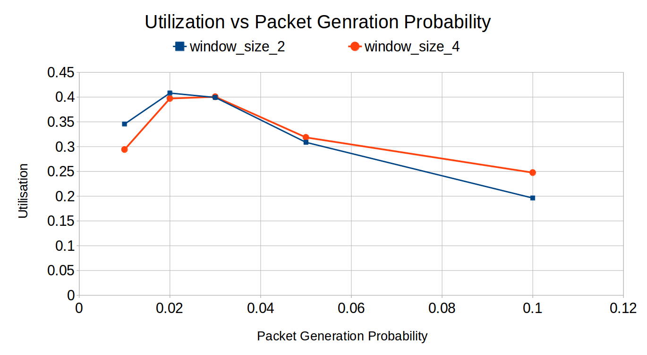

Utilization will only attain 1, in the case of no collision, because whenever collision occurs, corrosponding packet backoff counter gets initialized with the value between 0 and W-1, which causes the retransmission to occur.